Project Report: E-Commerce Sales Chatbot

1. Introduction

This report provides a comprehensive overview of the E-Commerce Sales Chatbot project. The project simulates a bookstore chatbot application allowing users to interact with a rule-based chatbot to discover and explore books by querying via natural language. It covers the technology stack used, workflow, sample test cases, the responses received, and insights gained throughout the development process.

1. Technology Stack

|  |  |
| --- | --- |
| Layer | Technology |
| Frontend | React, Axios, Custom CSS |
| Backend | Flask, Flask-Login, Flask-CORS |
| Database | MySQL |
| ORM | SQLAlchemy |
| Authentication | Werkzeug password hashing |

1. Architecture

1. Data Flow Diagram (DFD)A close-up of a sign

   AI-generated content may be incorrect.
2. Work Flow

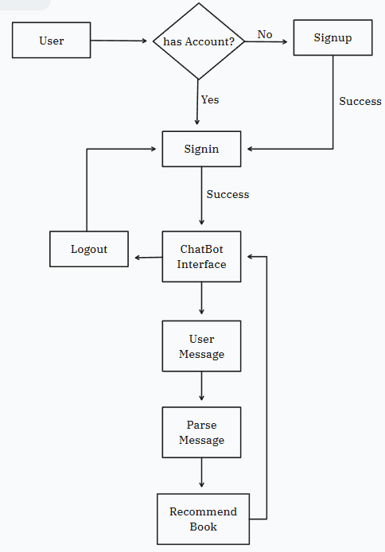

1. Entity Relationship Diagram (ER Diagram)

1. Sample Queries and Output

1. Problems Faced

* Implementing Regular Expressions (RegEx) for message parsing.
* Cross-origin request handling.
* Adding Custom CSS

1. Learnings

* Implemented full-stack integration of authentication, UI, and DB using Flask and React.
* Learned to handle CORS, secure sessions, and cross-origin cookies.
* Gained experience building rule-based NLP filters for structured search.
* Improved understanding of ORM, data modeling, and frontend-backend coordination.

1. Final Result

The chatbot was able to accurately parse and respond to user queries across a seeded dataset of 100+ mock book entries. It achieved a consistent interface for login, signup, and chat interaction. The system is modular, scalable, and extendable to commercial use cases.